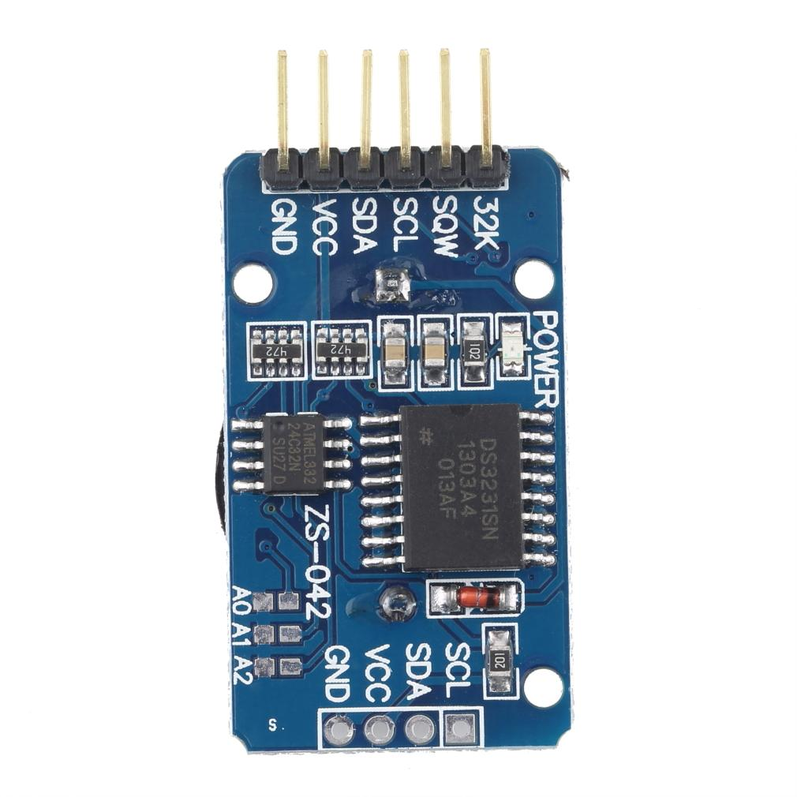

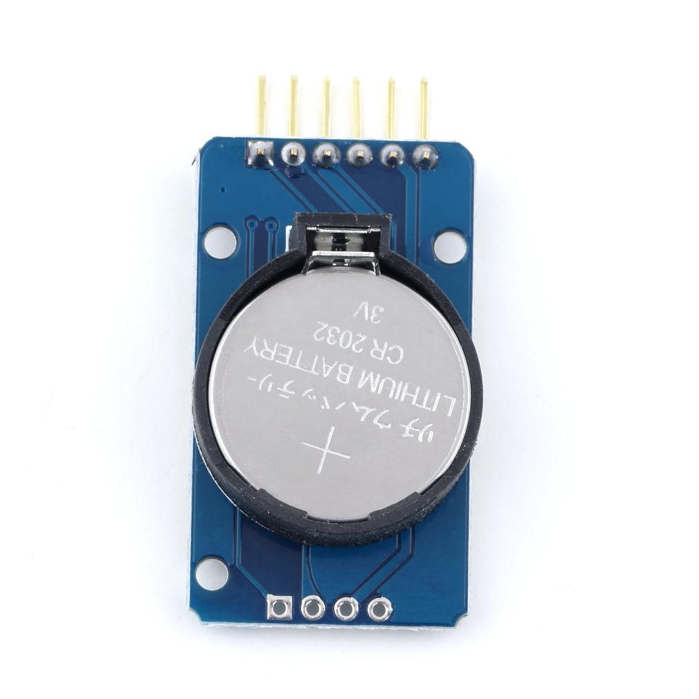

# **DS3231 AT24C32 IIC module precision Real time clock quare memory for Arduino HC**

# **Description:**

Module parameters:

1 Size: 38mm (length) * 22mm (W) * 14mm (height)

2 Weight: 8g

3 Operating voltage :3.3 - 5 .5 V

4 clock chip: high-precision clock chip DS3231

5 Clock Accuracy :0-40 ? range, the accuracy 2ppm, the error was about 1 minute

6 calendar alarm clock with two

7 programmable square-wave output

8 Real time clock generator seconds, minutes, hours, day, date, month and year timing and provide valid until the year 2100 leap year compensation

9 chip temperature sensor comes with an accuracy of ? 3 ?

10 memory chips: AT24C32 (storage capacity 32K)

11.IIC bus interface, the maximum transmission speed of 400KHz (working voltage of 5V)

12 can be cascaded with other IIC device, 24C32 addresses can be shorted A0/A1/A2 modify default address is 0x57

13 with rechargeable battery CR2032, to ensure the system after power failure, the clock move any natural normal

Package content:

1x Real Time Clock Module Memory Module

Fantastic Information and Tutorial for this device can be found here:

<http://tronixstuff.com/2014/12/01/tutorial-using-ds1307-and-ds3231-real-time-clock-modules-with-arduino/>